Current Commercial Data Processing Workflow

1. Data receipt
- Receives an email from the field via PMI secure file transfer.
- Uses the link in the email to download all files.
- Processing is performed on a dedicated, high-resource machine via remote desktop, not on a personal computer.

2. Initial download and folder setup
- Downloads all attachments to the local _Downloads_ folder.
- Runs a script that:
- Prompts for site ID and treatment number.
- Creates the required folder structure.
- Copies the downloaded ZIP files into those folders.
- Unzips the contents into the newly created directories.
- Deletes the original ZIP files after extraction.

3. Manual data organization
- Moves unzipped data into the appropriate folders:
- MRI
- TDC
- Treatment report
- Opens the treatment report PDF to confirm no patient-identifiable information is present, then closes it.

4. MRI handling
- Unzips the MRI DICOM archive.
- Deletes the ZIP after extraction.
- Does not rename or modify MRI files unless necessary.
- Relies on the site having selected de-identification during export.
- Performs spot checks if concerned about identifiers.
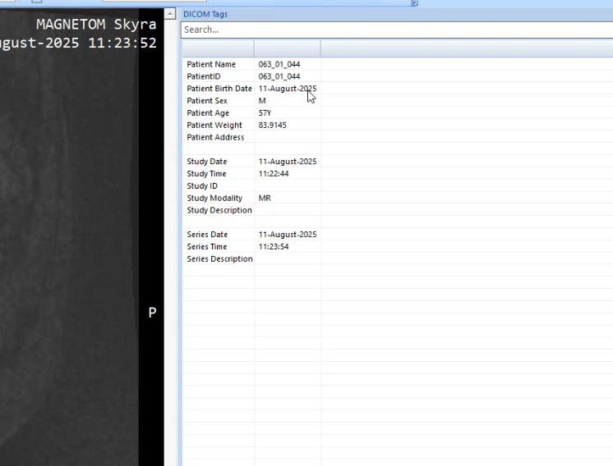
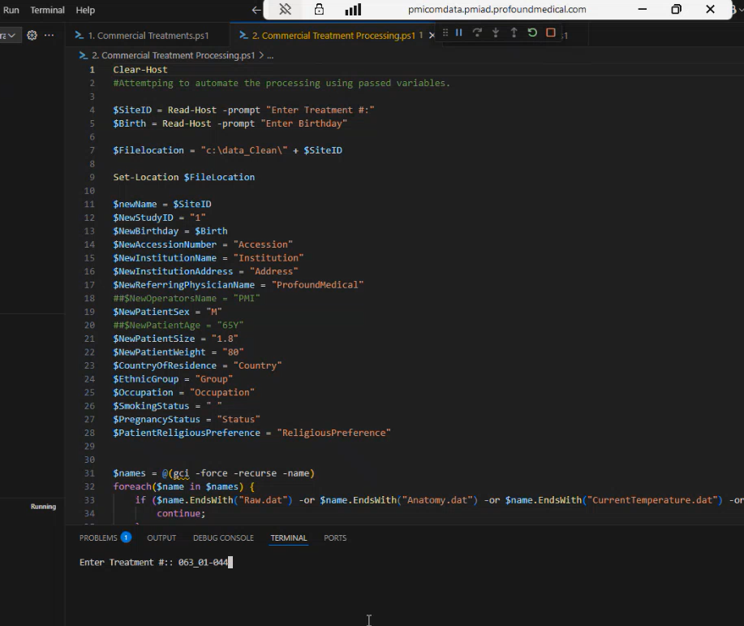
(19:28)

5. TDC handling
- Unzips the TDC archive.
- Deletes the ZIP after extraction.
- Renames or reorganizes folders as needed for consistency.
- Moves log folders (e.g., `Logs`) to the expected location (historically `applog`) for consistency with prior uploads.
- Re-zips TDC session folders and deletes the raw folders after compression.

6. Treatment tracking
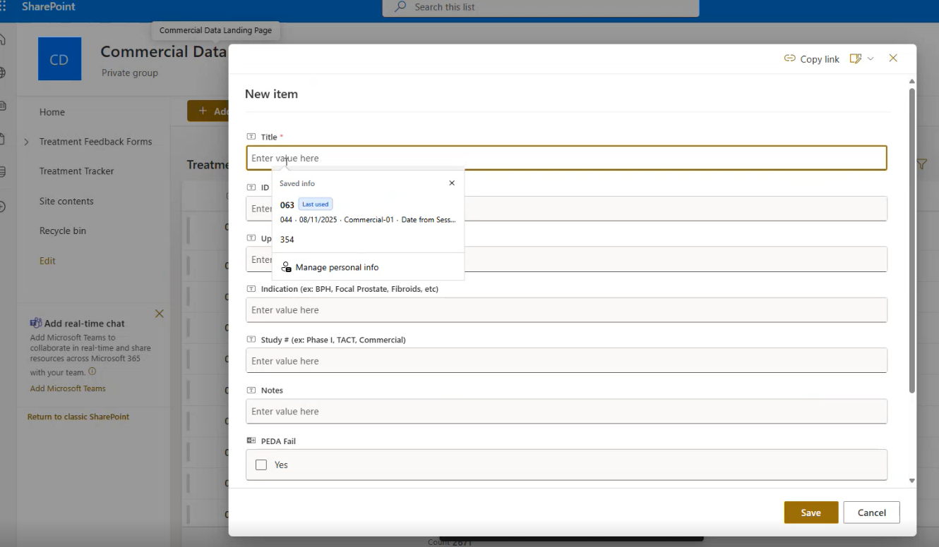
STAUS: currently do not have access to this (13:54)
- Updates the commercial treatment tracker manually:
- Site ID
- Treatment number
- Upload date (from the TDC session folder timestamp)
- Study designation (e.g., Commercial-01)
- Notes limited to non-PHI information
- Marks the treatment as “in processing.”

7. Local.db review
- Opens `local.db` manually using a SQLite browser.
- Checks patient-related columns (e.g., first name, last name, patient ID).
- If patient information is present:
- Deletes values from those fields.
- Preserves the remainder of the record.
- Closes the database after verification.

8. Running PEDA
- Right-clicks the treatment folder and selects “Run PEDA.”
(22:41)
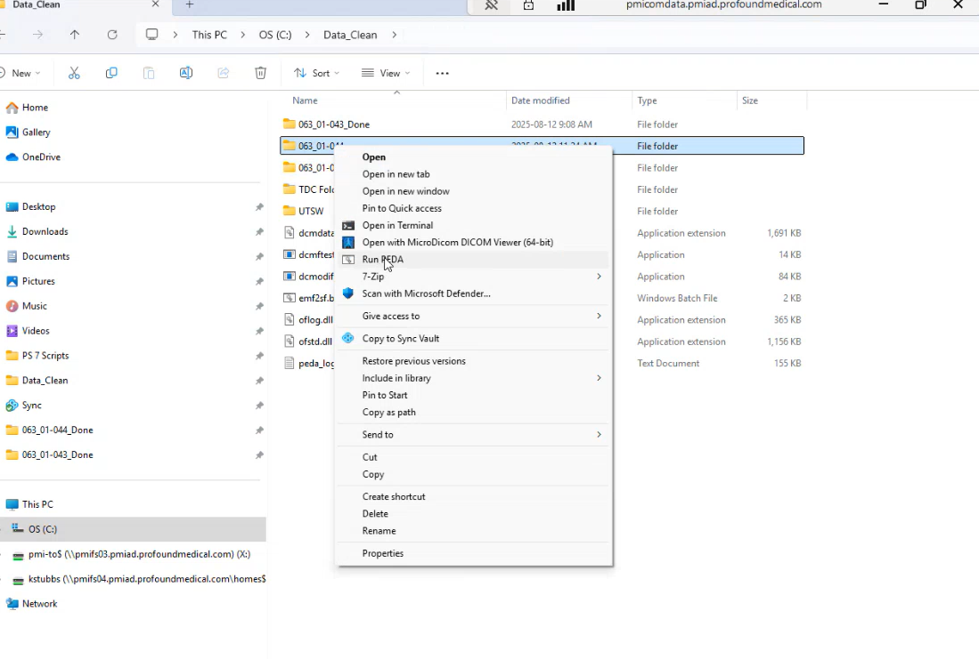
- PEDA executes via a batch file linked to the installed PEDA version.
- Does not interact with MATLAB directly.
- Monitors progress intermittently.
- If PEDA fails:
- Captures the failure output.
- Re-runs after other jobs complete to confirm whether failure was resource-related or data-related.
- Avoids running more than ~4 concurrent PEDA jobs.
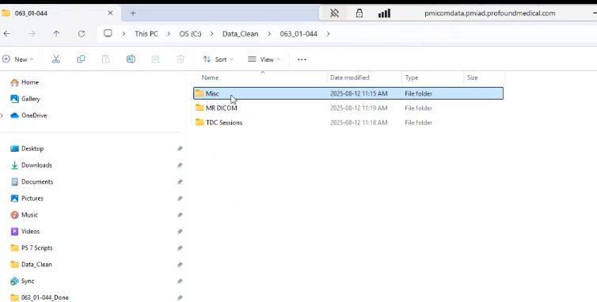
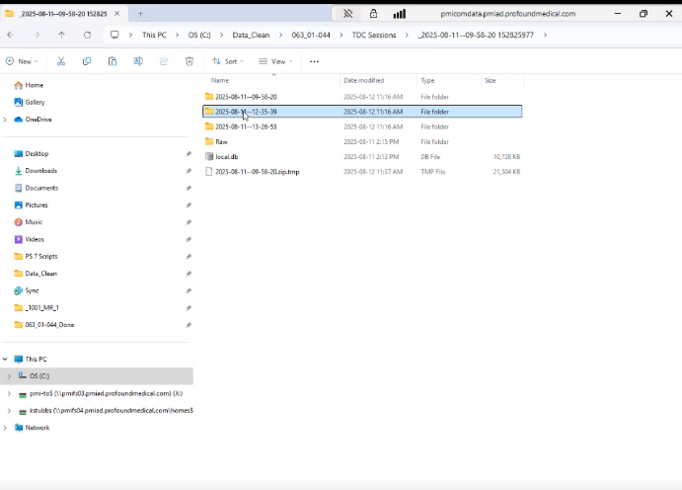
(22:16, 35:57) Just before PEDA run
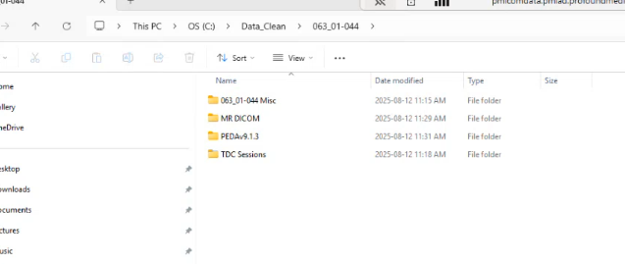
(35:54) Just after PEDA run
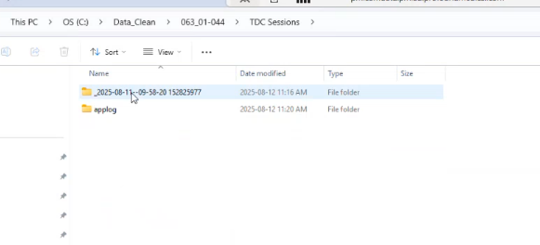
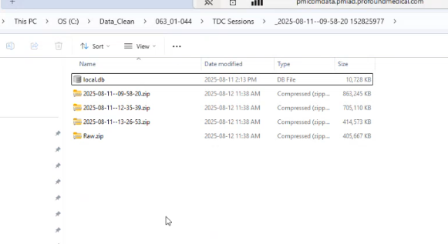
(38:13) What a TDC Session directory contains ( single session)
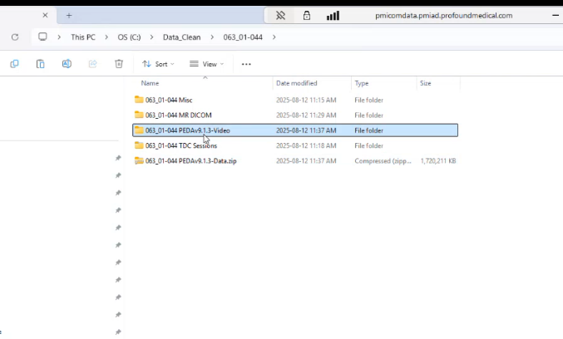
Delete .mat files from Video directory (easy script)

9. Post-PEDA cleanup
- Zips DICOM data, deleting raw folders after compression.
- Separates PEDA outputs into:
- Full PEDA data
- Video-only folders (with large `.mat` files removed)
- Uses an additional script to strip `.mat` files from video folders.
- Zips final PEDA artifacts.

10. Upload and vaulting
- Uploads all finalized ZIP files to Sync in one batch.
- Waits for upload confirmation.
- Moves uploaded files from Sync staging into the appropriate vault locations:
- DICOM
- TDC sessions
- PEDA data
- PEDA videos

11. Notification and closeout
- Sends a standardized notification email indicating:
- Site and treatment number
- Data uploaded
- PEDA run and uploaded
- Uses consistent wording for searchability.
- Marks the treatment as complete in the tracker.
- Copy the zipped TDC log to the Data Scientist NAS device for review.

File organization
Example
D:\Data_Clean\017_01-474\
│
├── 017_01-474 Misc\
│ └── 017_01-474_TreatmentReport.pdf
├── 017_01-474 MR DICOM\
│ └── 017_01-474_MRI.zip
├── 017_01-474 PEDAv9.1.3-Data.zip
└── 017_01-474 TDC Sessions\
├── applog\Logs\
│ └── 017-01-474_log.txt
└── Raw\2025-09-29\

Notes from “COM-00748 - IT DATA PROCESSING INSTRUCTIONS”
Input Example (Processor-Side)
Example case directory prior to processing:
D:\Data_Clean\017_01-474\
├── Misc\
│ └── 017_01-474_TreatmentReport.pdf
│
├── MR DICOM\
│ └── MRI_Export.zip
│
└── TDC Sessions\
└── _2025-11-05--07-05-25 122867438\
├── applog\
│ └── Logs\
└── Raw\
Notes:
- Input file and folder names may vary.
- Archives may be named inconsistently.
- Quoted Windows paths (“Copy as path”) are accepted.
- The pipeline does not require manual renaming.

Guaranteed Output Structure
After processing, each case must conform to the following structure:
I think this is not complete as the PEDA structure is missing; TODO
<Case_ID>\
├── Misc\
│ └── <Treatment Report PDF>
│
├── MR DICOM\
│ └── <Case_ID>_MRI.zip
│
└── TDC Sessions\
└── <Session_Name>\
├── applog\
│ └── Logs\
└── Raw\

